1. Now we have internal DB (H2).
2. Now time to connect with this DB to store Contact records coming from Contact Web Page from Eazy School Bytes Web App.
3. Now we have Web App and DB, so we require someone like API or Framework who can connect with DB and can understand DB’s language so that we can run our queries.
4. We have some tools like
   1. JDBC (API) from Core Java.
   2. Spring JDBC from Spring Framework.
   3. Spring Data JPA.
   4. Hibernate.
   5. Mybattis.
5. Confused with many tools for the same task.   
   No issue. We will start from the very basic tool Core JDBC and eventually we will discuss Spring Data JPA.

Core Java JDBC

1. It is a library that provides APIs to connect with any DB to execute our queries and then to fetch the results.
2. This API was used heavily earlier in 2000 as there was no framework.
3. But all the frameworks like Spring JDBC Template, JPA, Hibernate, Mybattis use JDBC Library.
4. 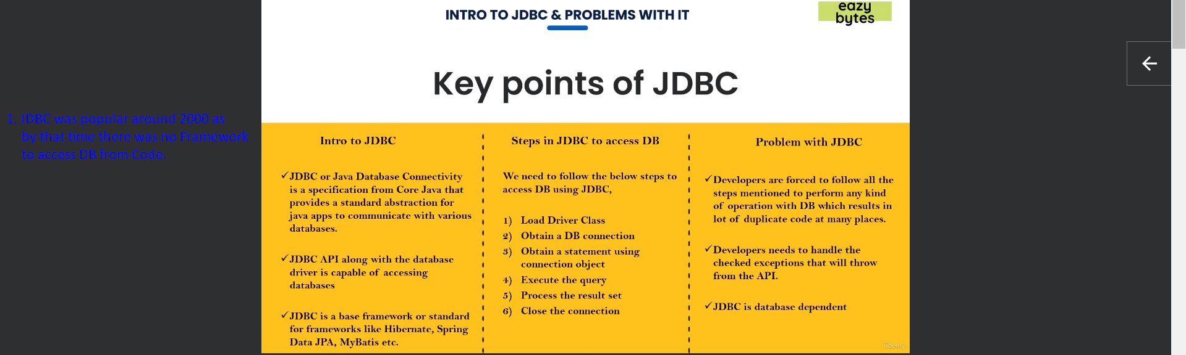
5. 
6. 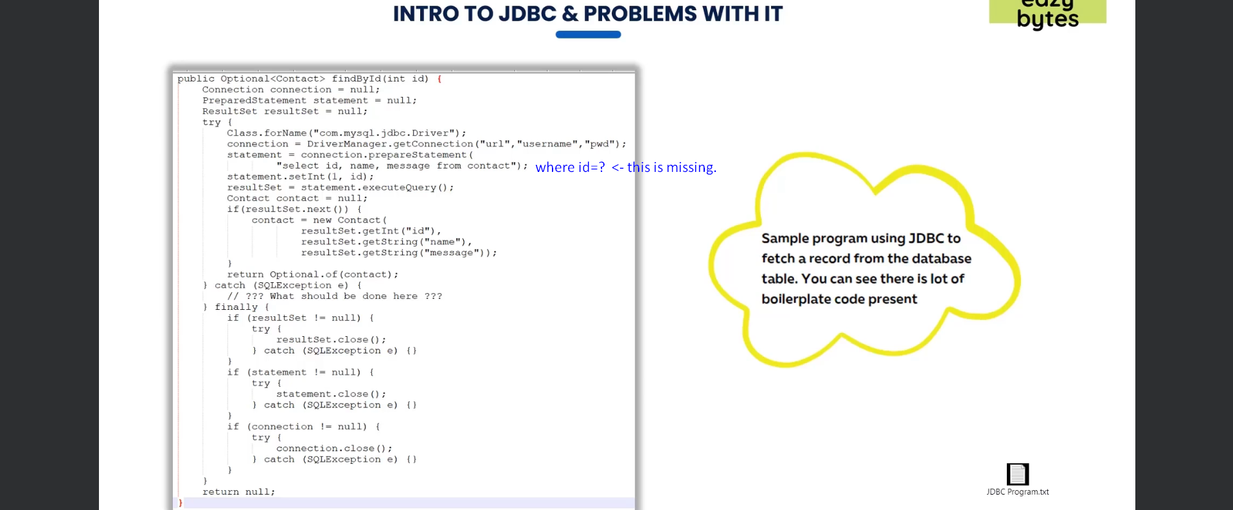
7. We have to make sure the following when writing code in Core JDBC.
   1. Queries are DB dependent.
   2. Setting Query Parameters, make sure calling appropriate methods like statement.setInt(1,id) as id is of type int.
   3. Iterating over result set and calling appropriate methods to fetch the values.
   4. Handling exceptions.
   5. Closing the result set, statement, connection.  
      ☹
8. Just to connect with DB for queries from your code, there are a lot of overheads which need to be tackled by the Developers.  
   So, Developers were looking for some solution.
9. Meanwhile, Spring Team came up with a nice framework Spring JDBC which handled most of these steps internally.